Section 1 CM 1020, Introduction to Engineering Graphics, Spring 2023
Mechanical Clamp CAD Breakdown Technical Report
Austin Miller & Anthony Graham

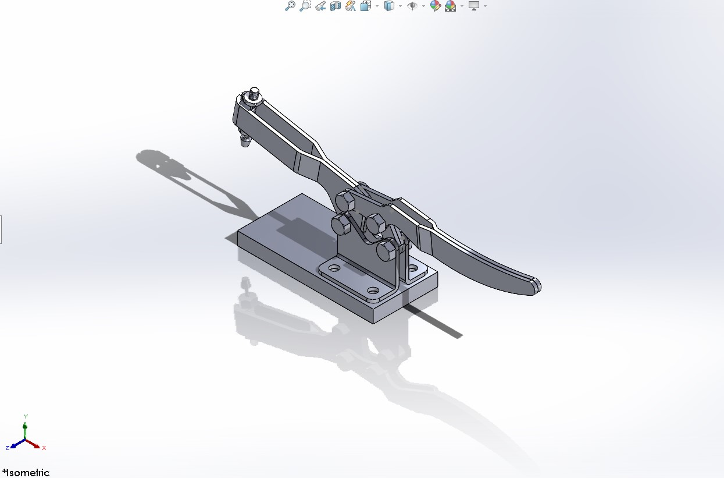
Figure 1: Fully constructed 3D model of mechanical clamp

A clamp is a fastening tool that uses inward pressure to hold various objects together or in place. Commonly used in engineering and construction, the many varying types of clamps exist due to differences in the object(s) the clamp must hold together and in which way they must be constructed. They are made up of 6 major components, each necessary for the successful use of the clamp and its function. Whether it be the lever arm, cross brace, or tamp, each component is used in conjunction with one other to create the pressure of the clamp.
Table of Contents
Table of Figures 2
Introduction 3
Exploded View 4

Component Descriptions 4
Lever Arm: 4
Rocker Arm: 5
Cross Brace: 5
Base: 6
Tamp: 7
Nuts & Washers: 7

Mechanism Description and Components 9
Summary/Conclusions 10
Appendix A 11
Appendix B 14

Table of Figures
Figure 1: Fully constructed 3D model of mechanical clamp 0
Figure 2: Exploded view of all individual components of mechanical clamp 4
Figure 3: 3D model of clamp’s lever arm 4
Figure 4: 3D model of clamp’s rocker arm 5
Figure 5: 3D model of clamp’s cross brace 5
Figure 6: 3D model of clamp's supporting base 6
Figure 7: 3D model of clamp's tamps 7
Figure 8: 3D model of an individual nut utilized in the mechanical clamp 7
Figure 9: 3D model of an individual bolt utilized in the mechanical clamp 7
Figure 10: 3D dimensioned drawing of nuts utilized in the clamp 11
Figure 11: 3D dimensioned drawing of bolts utilized in the clamp 11
Figure 12: 3D dimensioned drawing of the lever arm 11
Figure 13: 3D dimensioned drawing of the rocker arm 12
Figure 14: 3D dimensioned drawing of the cross brace 12
Figure 15: 3D dimensioned drawing of the clamp's supporting base 12
Figure 16: 3D dimensioned drawing of the tamps 13
Table 1: Bill of Materials 14

Introduction
A clamp is a mechanical device that is used to securely hold objects in place for others. Clamps typically consist of two jaws, one fixed and one movable, which are brought together using a screw or lever mechanism. The jaws are often lined with materials such as rubber or plastic to prevent damage to the object(s) being held. Various types of clamps are available, such as C-clamps, bar clamps, spring clamps, and pipe clamps, each with its own specific function. The primary function of a clamp is to exert strong and uniform pressure on the object being held, ensuring that it remains stationary and secure throughout all processes the object(s) may endure. Clamps are an essential tool in engineering and manufacturing, as they allow for secure positioning that holds materials in place during cutting, drilling, welding, and other mechanical processes.
This document will address in detail how the different components of a clamp work together to create a functional mechanism. It will explore the purpose and function of each component, such as the base, lever arm, rocker arm, cross brace, nuts, washers, and tamp. The essay will also examine how each component is manufactured, the appropriate materials to use, and how much it will cost to produce them. By understanding how each component functions and fits together, it is possible to gain a better understanding of how the clamp mechanism works. The aim is to provide a comprehensive overview of the clamp's mechanism and help produce a deeper appreciation of the engineering principles behind it.

Exploded View
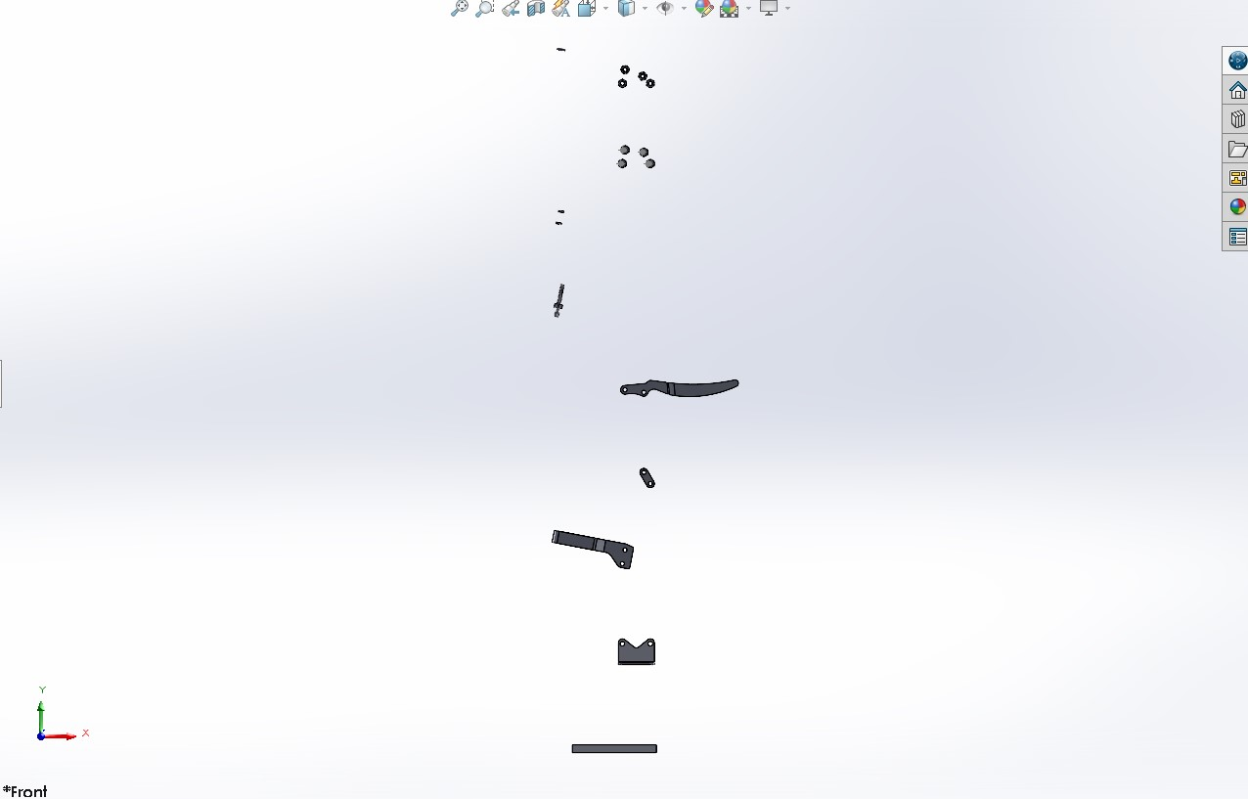

Figure 2: Exploded view of all individual components of mechanical clamp

Component Descriptions

Lever Arm:
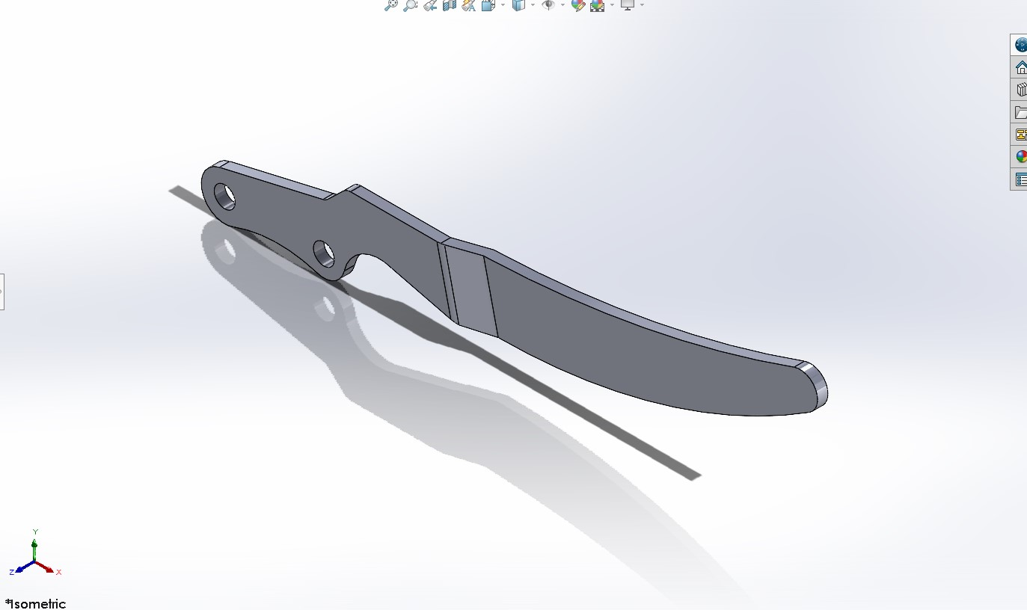
The lever arm in a clamp serves as the main mechanism for tightening and loosening the clamp. It is designed to apply clamping pressure to an object within the clamp with minimal effort. The lever arm can be manufactured through various methods such as casting, forging, or machining, depending on the required size and complexity of the clamp. The cost to manufacture a lever arm for a clamp will depend on factors such as the material used, the manufacturing method, and the quantity produced. For instance, a simple lever arm made of aluminum can cost between $5 and $20 to produce, while a more complex or larger lever arm made of a high-grade alloy can cost significantly more. The appropriate material for a lever arm will depend on the application and requirements of the clamp, but materials commonly used include steel, aluminum, brass, and titanium. These materials offer high strength, durability, and corrosion resistance, making them useful for a variety of engineering applications.
Figure 3: 3D model of clamp’s lever arm

Rocker Arm:
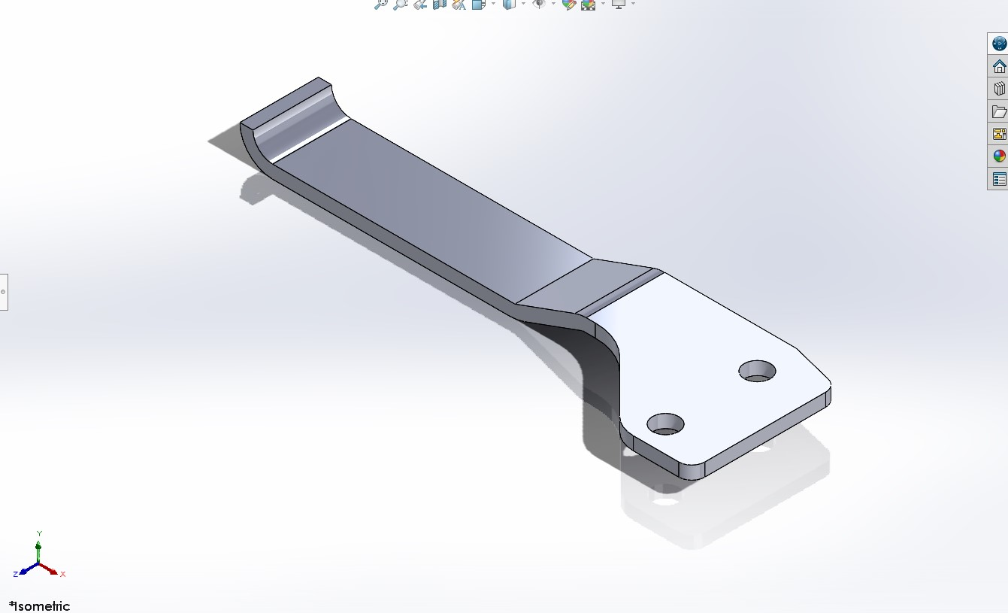
The rocker arm in a clamp is a vital component that creates the movement of the movable jaw in the clamp. Its main purpose is to transfer the motion of the lever arm to the movable jaw, which then applies the force to the object being held. The rocker arm is typically made using a variety of manufacturing methods such as casting, forging, or machining, depending on the desired size and complexity of the clamp. The cost to manufacture a rocker arm for a clamp will depend on the material used, the manufacturing method, and the quantity produced. Its pricing is like that of the lever arm. The appropriate material for a rocker arm will depend on the purpose and requirements of the clamp, but materials commonly used are those used for a lever arm as well.
Figure 4: 3D model of clamp’s rocker arm

Cross Brace:
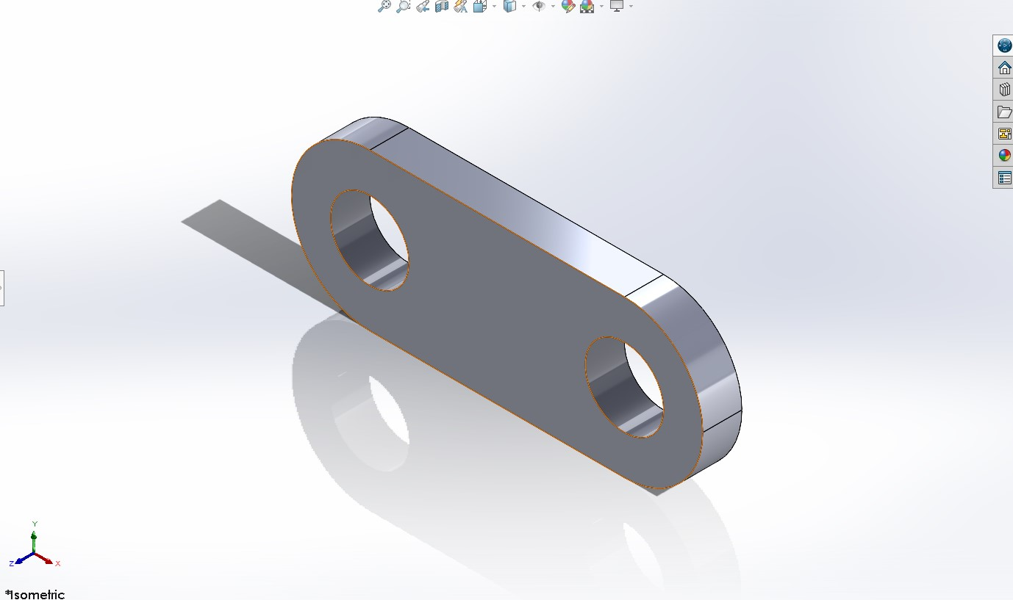
The cross brace in a clamp serves as a stabilizing component that helps to maintain the alignment and rigidity of the clamp during use. Its main purpose is to prevent the jaws from flexing or bending under the clamping pressure, which can compromise the quality and accuracy of the workpiece. The cross brace is typically made using a variety of manufacturing methods such as casting, forging, or machining, depending on the desired size and complexity of the clamp. The cost to manufacture a cross brace for a clamp will depend on the material used, the manufacturing method, and the quantity produced. Its pricing is like that of the lever arm. The appropriate material for a cross brace will depend on the purpose and requirements of the clamp, but materials commonly used are those used for a lever arm as well.
Figure 5: 3D model of clamp’s cross brace

Base:
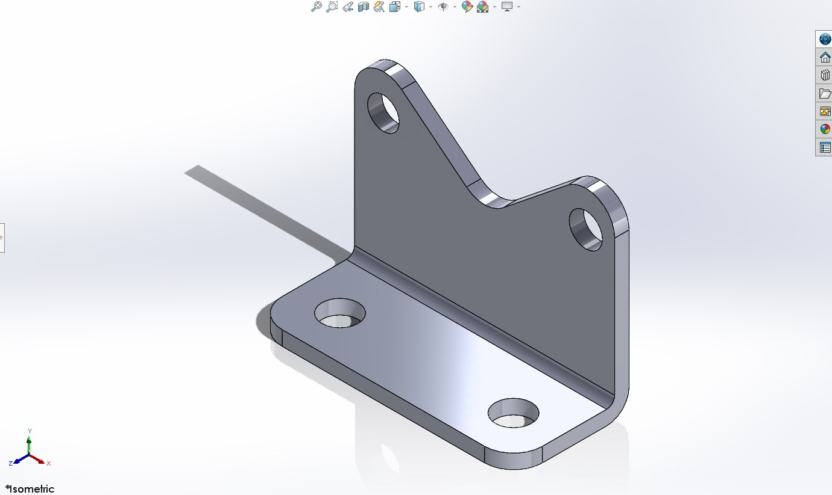
The base of a clamp serves as the foundation for the entire clamp. Its primary purpose is to provide stability and support to the clamp during use, preventing it from tipping or shifting. The base is typically made using various manufacturing methods such as casting, forging, or machining, depending on the desired size and complexity of the clamp. The cost to manufacture a base for a clamp will depend on factors such as the material used, the manufacturing method, and the quantity produced. The appropriate material for a base will depend on the application and requirements of the clamp, but materials commonly used include steel, cast iron, and aluminum. These materials offer high strength, durability, and stability, making them suitable for use in a variety of engineering applications. The base may also have additional features such as mounting holes or leveling mechanisms, depending on the specific requirements of the application for the clamp.
Figure 6: 3D model of clamp's supporting base

Tamp:
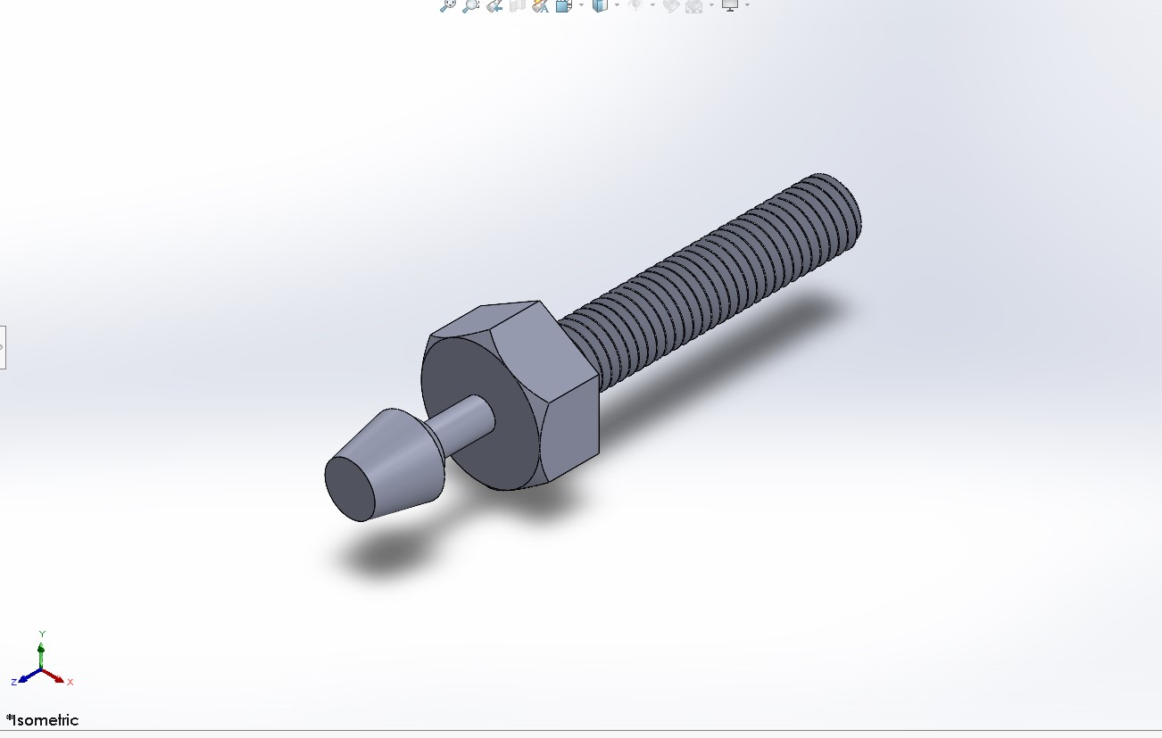
The tamp is the component that allows for the secure hold of objects in between the jaws, enabling the clamp to be tight and safe. Its main purpose is to provide a comfortable grip for objects being held to decrease the chances of damage due to the clamping pressure. The tamp is typically made using various manufacturing methods such as injection molding, machining, or casting, depending on the desired size and complexity of the clamp. The cost to manufacture a knob for a clamp will depend on factors such as the material used, the manufacturing method, and the quantity produced. The appropriate material for a knob will depend on the application and requirements of the clamp, but materials commonly used include plastic, aluminum, rubber, and steel.
Figure 7: 3D model of clamp's tamps

Nuts & Washers:
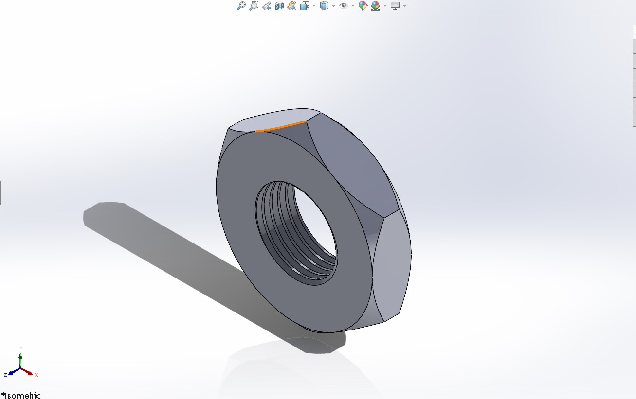
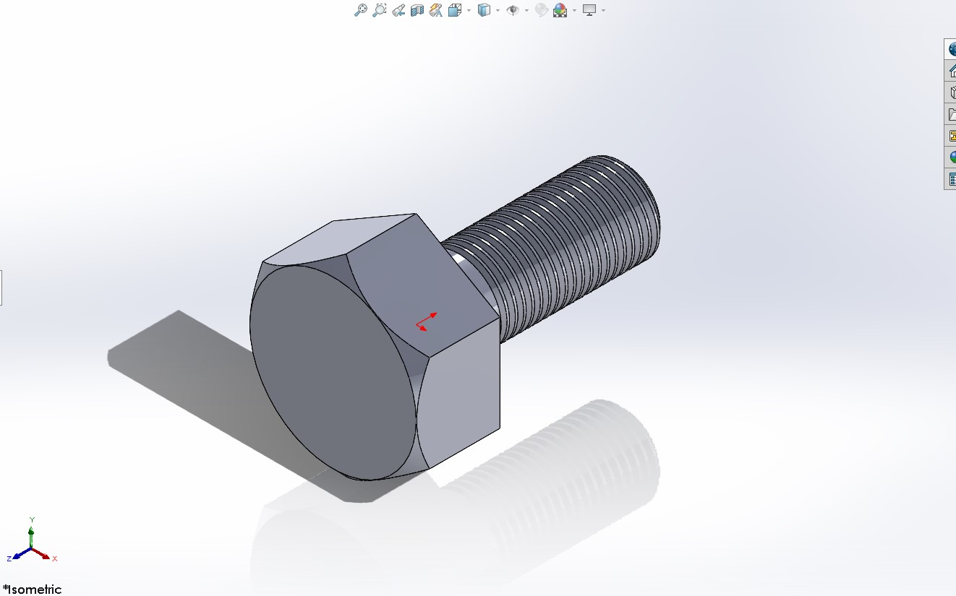
The nuts and washers in a clamp play a crucial role in securing the movable jaw and adjusting the clamping pressure. Their main purpose is to provide a strong and reliable connection between the clamp's components while also allowing for easy adjustment and tightening. The nuts and washers are typically made using various manufacturing methods such as cold forming, hot forging, or machining, depending on the desired size and complexity of the clamp. The cost to manufacture nuts and washers for a clamp will depend on factors such as the material used, the manufacturing method, and the quantity produced. The appropriate material for nuts and washers will depend on the application and requirements of the clamp, but materials commonly used include steel, brass, bronze, and stainless steel. These materials offer high strength, corrosion resistance, and durability, making them suitable for use in a variety of engineering applications.
Figure 8: 3D model of an individual nut utilized in the mechanical clamp
Figure 9: 3D model of an individual bolt utilized in the mechanical clamp

Mechanism Description and Components
The assembly of a clamp can vary depending on the design and intended use of the clamp. The basic components of a clamp include a base, lever arm, rocker arm, cross brace, nuts, washers, and a tamp. To assemble a clamp, the base is typically secured to a flat surface, and the lever arm is attached to the rocker arm using bolts or screws. The lever and rocker arm are then attached to the base using a pivot point, allowing it to move up and down to apply pressure to the object that will be used. The cross brace provides additional stability, while the tamp is attached to the rocker arm using bolts or screws, completing the assembly process.
The way a clamp is assembled can affect how it functions. For example, some clamps may have an additional locking mechanism to prevent accidental release of the movable jaw, which can be particularly important in applications where safety is a concern. Other clamps may have different types of jaws to allow specific materials or methods. The choice of materials can also affect how the clamp functions, with some materials providing greater durability and damage resistance. By understanding the different components of a clamp and how they can be assembled in various ways, it is possible to select a clamp that is appropriate for a particular application and use it effectively.

Summary/Conclusions
In conclusion, clamps are a widely used tool that provides a simple and effective way to hold objects or materials together securely. The assembly of a clamp typically involves attaching the various components, such as the base, lever arm, rocker arm, cross brace, nuts, washers, and tamp in a way that allows pressure to be applied to the objects being held. The specific design and function of a clamp can vary depending on the intended use, with different types of jaws, locking mechanisms, and materials available to accommodate different applications.
Overall, the versatility of clamps makes them an essential tool for many industries, including woodworking, manufacturing, and construction. By understanding the various components of a clamp and how they work together to provide a secure hold, it is possible to select a clamp that is appropriate for a particular application and use it effectively. With proper use and maintenance, a clamp can provide reliable performance for years to come, making it a valuable addition to any workshop or job site.

Appendix A
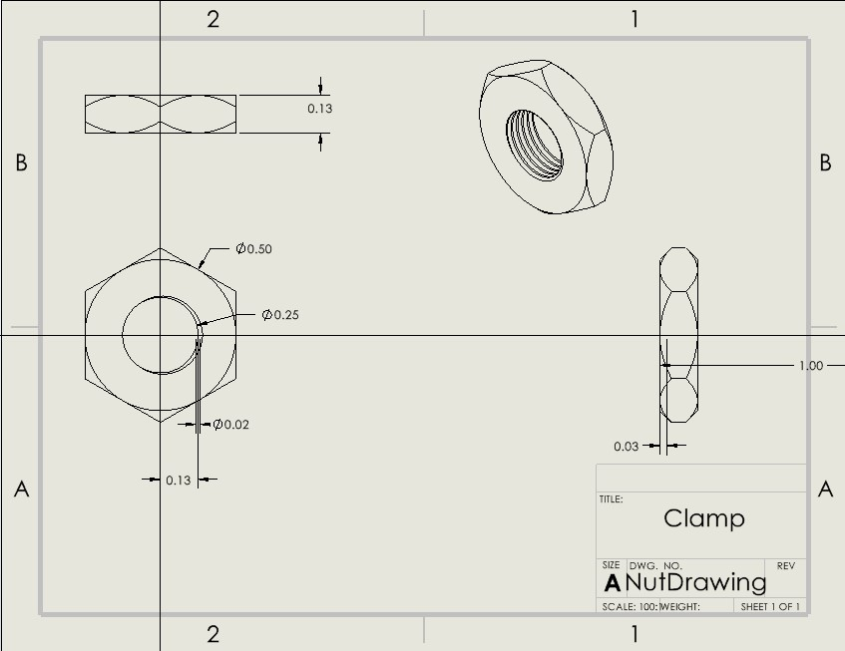
Figure 10: 3D dimensioned drawing of nuts utilized in the clamp
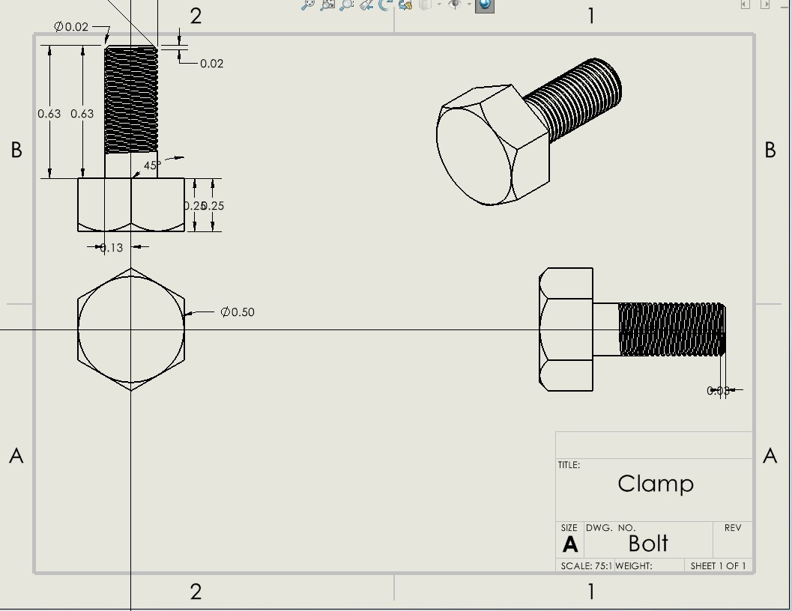
Figure 11: 3D dimensioned drawing of bolts utilized in the clamp
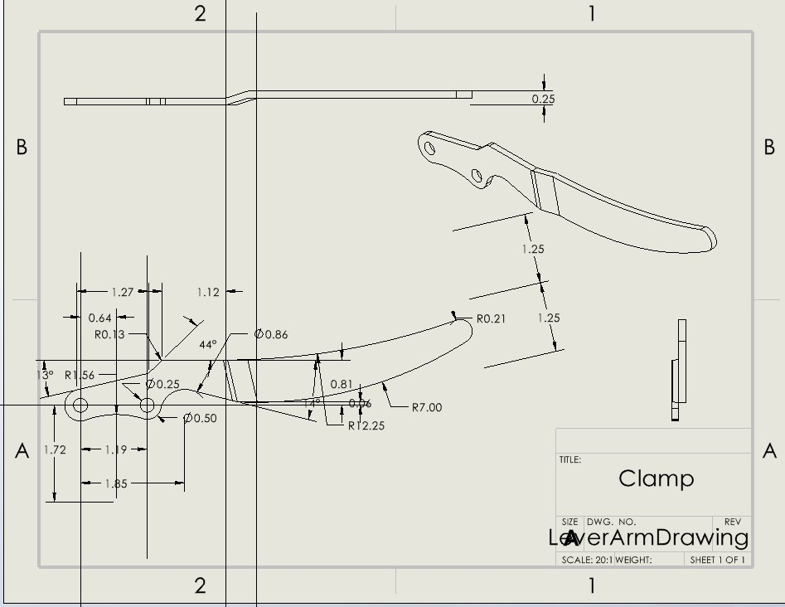
Figure 12: 3D dimensioned drawing of the lever arm
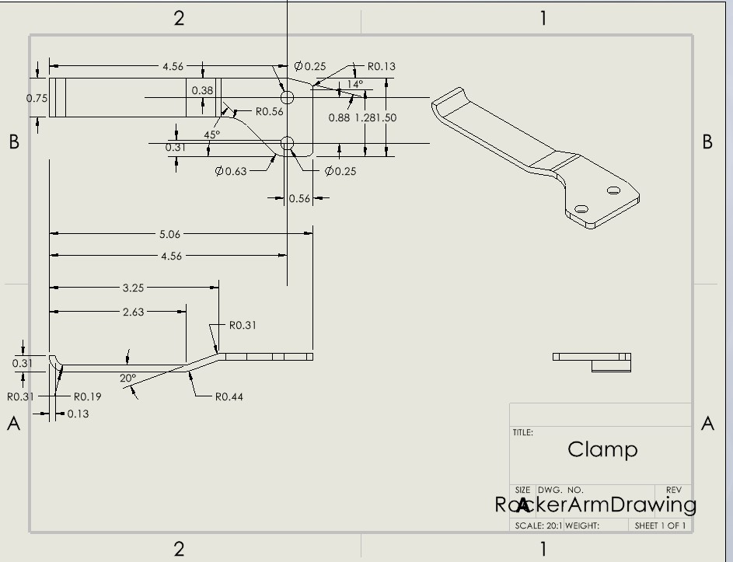
Figure 13: 3D dimensioned drawing of the rocker arm
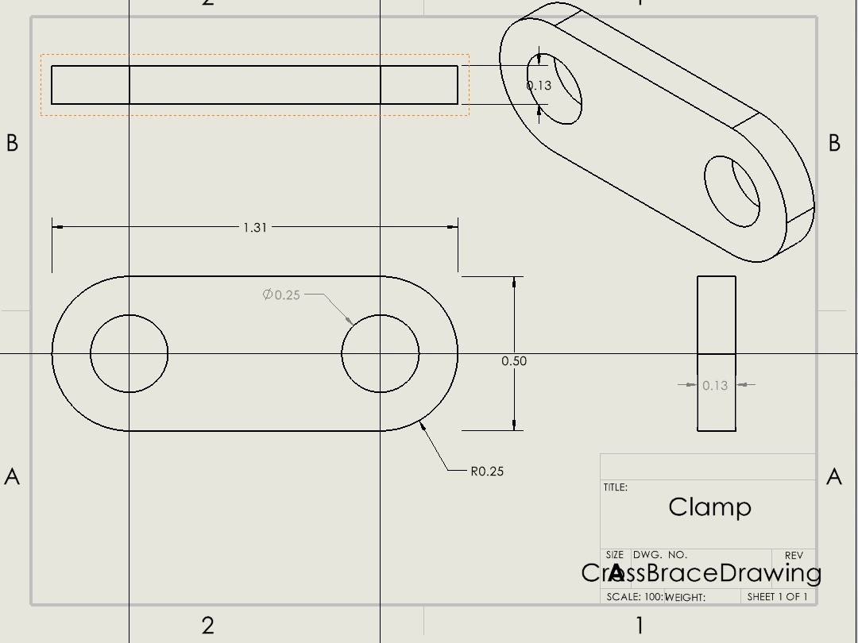
Figure 14: 3D dimensioned drawing of the cross brace
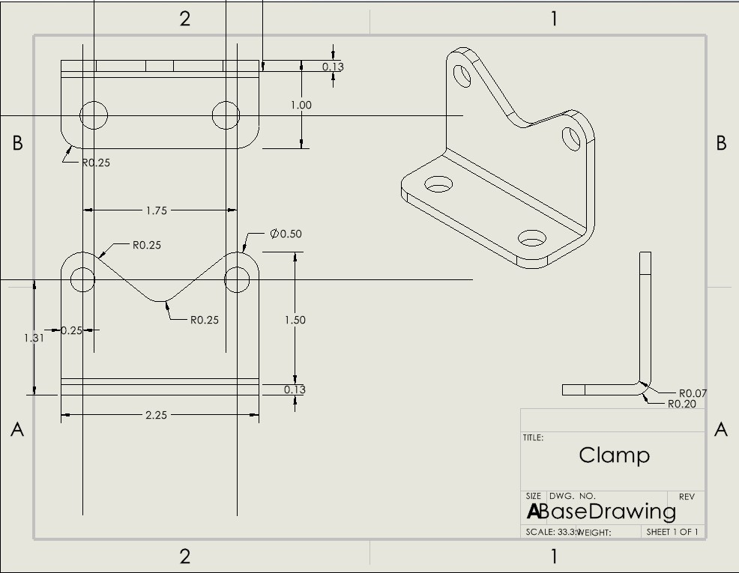
Figure 15: 3D dimensioned drawing of the clamp's supporting base

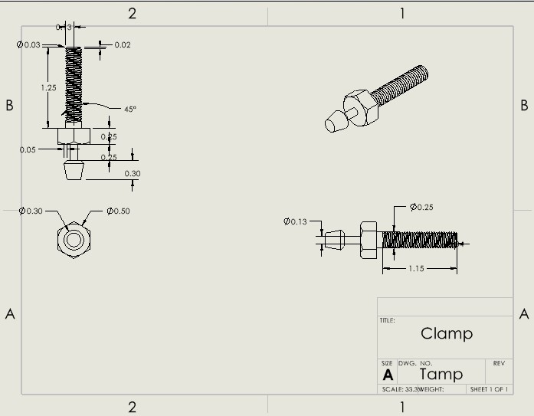
Figure 16: 3D dimensioned drawing of the tamps

Appendix B
ITEM NO. | Part Number | Item Description | QTY.
1 | Base | Stable Foundation for the clamp to be secured to | 2
2 | Lever Arm | Leveraging handle used to open and close the grip of the clamp | 2
3 | Rocker Arm | Handle used to allow movement for the jaws of the clamp | 2
4 | Cross Brace | Stabilizers for security and function efficiency | 2
5 | Tamp | The contacting component used to secure object(s) within the clamp using pressure | 1
6 | Nuts & Washers | Fasteners used to secure components of the clamp | 4 - 4
Table 1: Bill of Materials

